Module 5: Factors, Divisibility and Mathematical Loops
Question 2: 326. Power of Three
Platform: LeetCode
Difficulty: Easy
Problem Link: https://leetcode.com/problems/power-of-three/
Problem Statement
Given an integer n, return true if it is a power of three. Otherwise, return false.
An integer n is a power of three if there exists an integer x such that n == 3^x.
Examples
Example 1:
- Input: n = 27
- Output: true
- Explanation: 27 = 3³.
Example 2:
- Input: n = 0
- Output: false
Example 3:
- Input: n = -1
- Output: false
Constraints
- -2³¹ <= n <= 2³¹ - 1
Code Screenshot
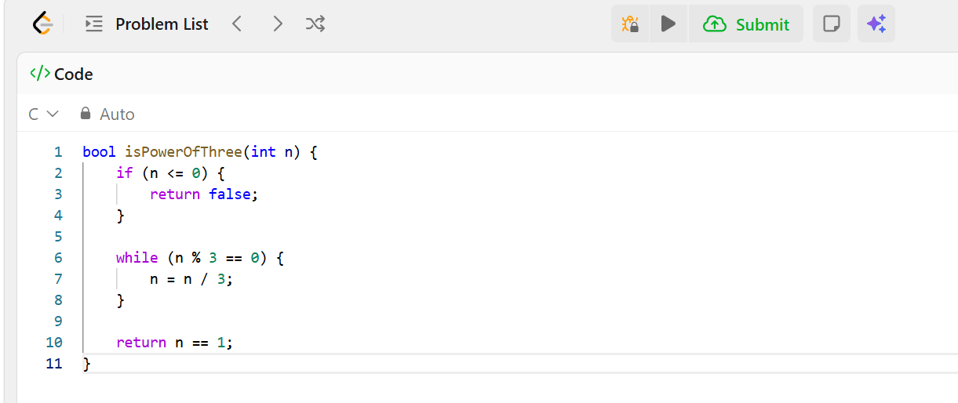Output Screenshot
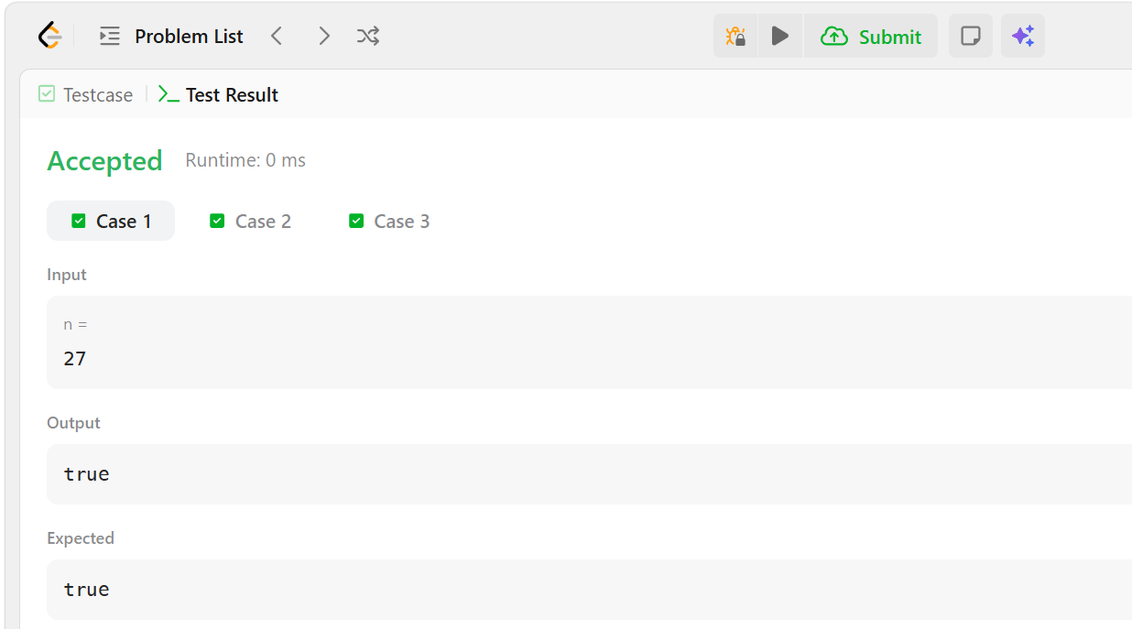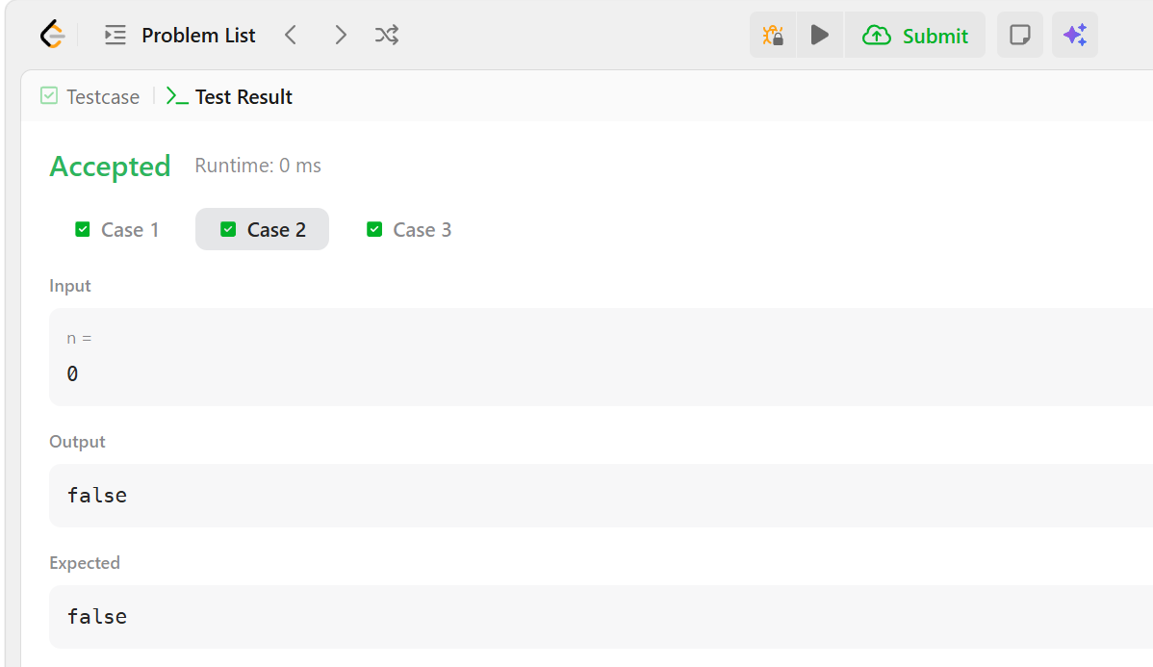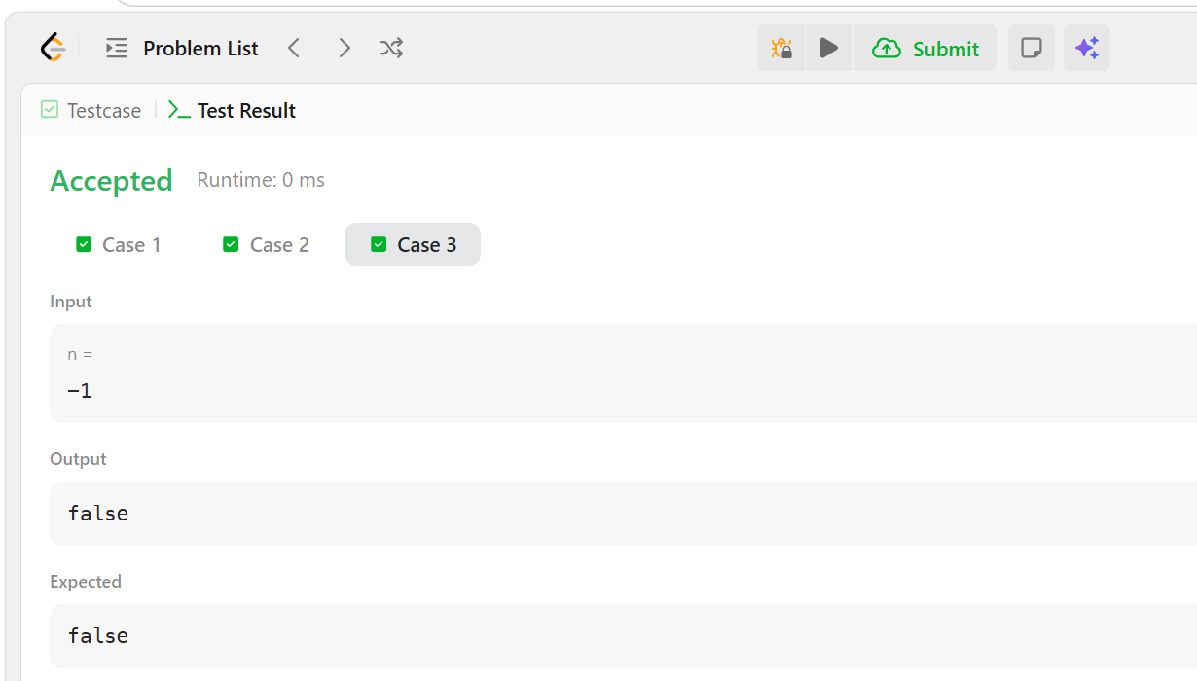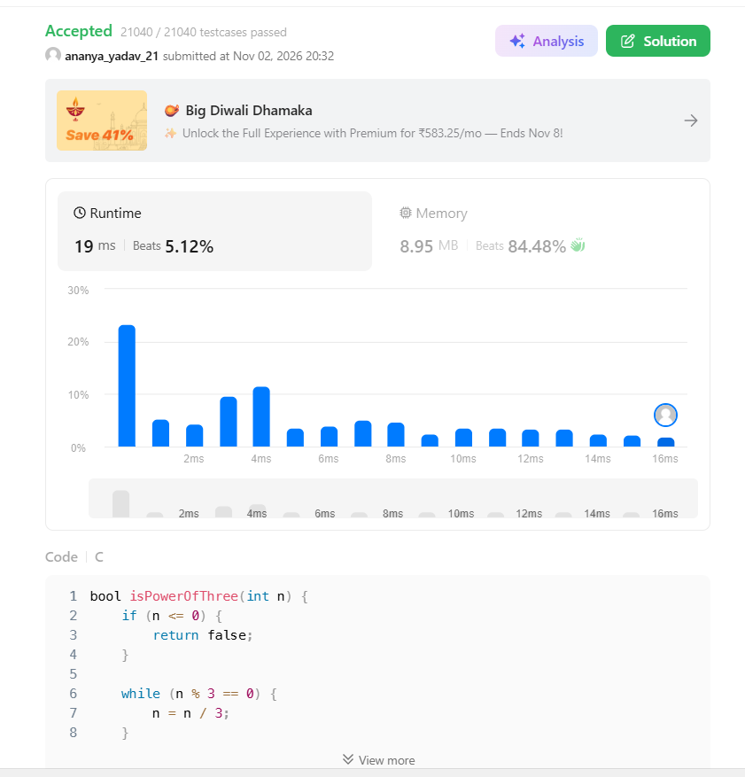Result
The program checks whether the given integer is a power of three. Platform: LeetCode.

